Intro to SQL Commands - DQL

✅ What is SQL Commands – DQL (Data Query Language)?
# Source: AI Source: Provided by: [Data Path: Persons Table -> ID Column: 1, Name_En Column: Motasem Essam] -> From: [ChatGPT] on [6/11/2026]
DQL stands for Data Query Language, and it includes SQL commands used to retrieve data from a database — without modifying it.

🧩 Core DQL Command:
# Source: AI Source: Provided by: [Data Path: Persons Table -> ID Column: 1, Name_En Column: Motasem Essam] -> From: [ChatGPT] on [6/11/2026]
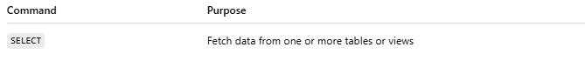
Command | Purpose
SELECT | Fetch data from one or more tables or views

📘 Example:
# Source: AI Source: Provided by: [Data Path: Persons Table -> ID Column: 1, Name_En Column: Motasem Essam] -> From: [ChatGPT] on [6/11/2026]
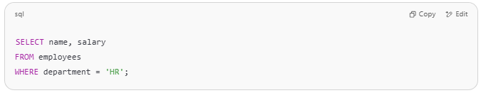
SELECT name, salary
FROM employees
WHERE department = 'HR';

This query:
- Does not change data
- Simply retrieves rows that match the condition

🔍 DQL is often combined with:
# Source: AI Source: Provided by: [Data Path: Persons Table -> ID Column: 1, Name_En Column: Motasem Essam] -> From: [ChatGPT] on [6/11/2026]
- Filtering (WHERE)
- Sorting (ORDER BY)
- Grouping (GROUP BY)
- Joins (e.g., combining data from multiple tables)
- Functions (like COUNT(), AVG())

✅ Key Points:
# Source: AI Source: Provided by: [Data Path: Persons Table -> ID Column: 1, Name_En Column: Motasem Essam] -> From: [ChatGPT] on [6/11/2026]
- DQL is read-only — it doesn’t add, delete, or update data.
- It’s the most commonly used type of SQL, especially in reporting and analytics.
- It’s often used in combination with DML when building applications.

